**Project Design Phase-II**

**Technology Stack (Architecture & Stack)**

|  |  |
| --- | --- |
| Date | 26 October 2022 |
| Team ID | PNT2022TMID15139 |
| Project Name | Smart Farmer- IoT Enabled Smart Farming Application |
| Maximum Marks | 4 Marks |

**Technical Architecture:**

The Deliverable shall include the architectural diagram as below and the information as per the table1 & table 2

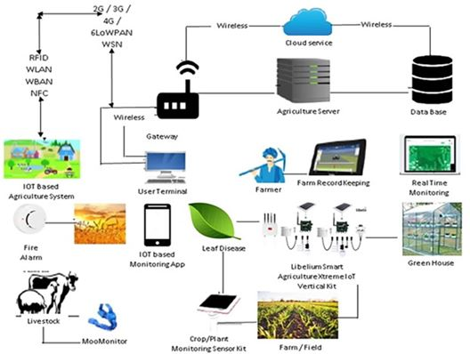

Real Time Kinetic Workflow Technical Architecture

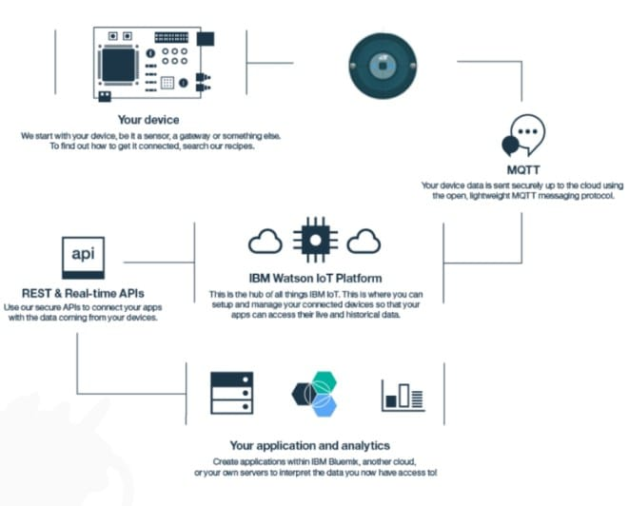

IBM Network Workflow

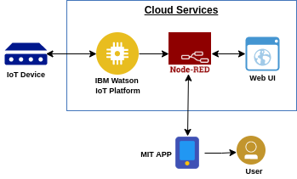

Simulative Profile Workflow Architecture

**Table-1: Components & Technologies:**

|  |  |  |  |
| --- | --- | --- | --- |
| **S.No** | **Component** | **Description** | **Technology** |
|  | User Interface | User Interaction by means of Application software | MIT app |
|  | Application Logic-1 - Circuit Design | To provide the functional outflow | Node red |
|  | Application Logic-2 - Data Accessibility | Data transfer and Usage | IBM Watson |
|  |  |  |  |
|  | Database | Physically varying environmental parameters | MySQL |
|  | Cloud Database | Database Service on Cloud | IBM cloud. |
|  | Temperature sensor | Monitors the temperature of the crop | DS18B20 |
|  | Humidity sensor | Monitors the humidity | DHT11 |
|  | Soil moisture sensor (Tensiometers) | Monitors the soil temperature | FC28 |
|  | Weather sensor | Monitors the weather | F611 |

**Table-2: Application Characteristics:**

| **S.No** | **Characteristics** | **Description** | **Technology** |
| --- | --- | --- | --- |
|  | Open-Source Frameworks | MIT app,Node-Red | Software |
|  | Scalable Architecture | Measurement of physically  varying environmental conditions | Hardware-Sensor nodes and  Wifi Modules |